QUANTITATIVE FINANCE STUDY GUIDE
Monte Carlo Simulation in Quantitative Finance
From first principles to derivatives pricing, portfolio risk and interview preparation
- Intuition, mathematics, worked examples and executed Python in one sequence
- Option pricing, variance reduction, VaR / Expected Shortfall, Asian and other path-dependent options
- Ten interview questions, five numerical / coding problems, formula sheet and glossary
How the numbers in this guide were produced
Every numerical result, table value and chart was produced by executing the Python code shown in the guide (Python 3 with NumPy, SciPy, pandas and Matplotlib) with fixed random seeds. Nothing is quoted from memory. Where a quantity has a closed-form value (for example Black–Scholes) it is computed separately and labelled as the theoretical value; Monte Carlo output is labelled as an estimate.
This guide is educational material. It is not investment advice, and the illustrative models are deliberately simple.
October 2026
Contents
1. Introduction and Intuition 3
1.1 What Monte Carlo simulation is 3
1.2 A real-world analogy 3
1.3 Why it is useful in finance 3
1.4 How to use this guide 3
2. Probability and Statistical Foundations 4
2.1 Random variables and distributions 4
2.2 Expected value, variance and standard deviation 4
2.3 The Monte Carlo estimator and the Law of Large Numbers 4
2.4 Central Limit Theorem, standard error and confidence intervals 4
2.5 Why the error falls like 1/√N 5
3. Building a Simulation 5
3.1 The six-step workflow 5
3.2 Worked example: an expected value 6
3.3 Estimating π by random sampling 6
3.4 Seeing the 1/√N law 7
4. Simulating Asset Prices 8
4.1 Brownian motion 8
4.2 Geometric Brownian Motion 8
4.3 Simulating many paths 9
4.4 Limitations of GBM 10
5. Monte Carlo Option Pricing 10
5.1 Risk-neutral valuation 10
5.2 The Monte Carlo option estimator 11
5.3 Worked example versus Black–Scholes 11
5.4 Sensitivity to volatility, maturity and simulation count 12
6. Variance Reduction 13
6.1 Antithetic variates 13
6.2 Control variates 13
6.3 Importance sampling 13
6.4 Quasi-Monte Carlo 13
7. Portfolio Risk Management 15
7.1 Simulating correlated returns 15
7.2 Value at Risk and Expected Shortfall 15
7.3 Worked example: four-asset portfolio 16
7.4 Correlation, tail risk and model limitations 17
8. Path-Dependent Derivatives 18
8.1 Why full paths are needed 18
8.2 Worked example: arithmetic-average Asian call 18
8.3 Barrier and lookback options, and monitoring bias 19
8.4 American options and least-squares Monte Carlo 19
9. Limitations and Practical Pitfalls 20
9.1 Sampling error, bias and model risk 20
9.2 Frequent implementation errors 20
9.3 Unrealistic assumptions in trading applications 21
10. Integrated Case Study and Interview Revision 21
10.1 Case study: pricing an option and assessing downside risk 21
10.2 Ten interview questions with answers 22
10.3 Five numerical and coding questions 22
10.4 Formula sheet 23
10.5 Glossary 23
10.6 Further reading and references 24

1. Introduction and Intuition

1.1 What Monte Carlo simulation is
Monte Carlo simulation answers a quantitative question by running a random experiment many times and averaging the results. Instead of solving for an answer analytically, we describe how the uncertain quantity behaves, generate thousands or millions of plausible outcomes on a computer, and read the answer off the collection of outcomes. The name comes from the casino in Monaco, a reference to the role of chance; the method was developed in the 1940s for problems in nuclear physics and was introduced to option pricing by Boyle (1977).
The idea rests on one fact: an expected value is a long-run average. If we can simulate the random inputs and compute the payoff or loss that results, then the average of many simulated payoffs approximates the expected payoff. Almost every important quantity in finance is an expected value of something: a derivative's price is a discounted expected payoff, a portfolio's risk measure is a property of an expected loss distribution, and the value of a trading rule is its expected profit.

1.2 A real-world analogy
Imagine you want to know the chance that a commuter train arrives more than ten minutes late. You could try to model signalling, weather, crowding and engineering faults analytically, which is hopeless. Alternatively you can simply record 1,000 journeys and count how many were late. Monte Carlo does exactly this, except the journeys are generated by a computer model rather than observed. The model's job is to be realistic enough; the simulation's job is to turn that model into numbers. A weather forecaster who runs a model fifty times with slightly different starting conditions and reports “70% chance of rain” because 35 runs rained is doing Monte Carlo.

1.3 Why it is useful in finance
Closed-form prices exist only for a small set of simple contracts under simple models. Monte Carlo is valuable because its accuracy does not depend on the dimension of the problem in the way that grid-based numerical methods do: the error shrinks like 1/√N whether the payoff depends on one asset or on fifty, and whether it depends on the final price only or on the whole price path. This makes it the default tool when a problem has many risk factors, path dependence, or an awkward payoff.
Table 1. Typical applications of Monte Carlo simulation in finance
Area | Question answered | What is simulated
Derivatives pricing | What is a fair price for an exotic or path-dependent option? | Risk-neutral asset-price paths; discounted payoff
Portfolio risk | How much could we lose over 10 days at 99% confidence? | Correlated returns for every risk factor; portfolio P&L
Scenario analysis / stress | What happens to the book if rates and equities fall together? | Joint shocks drawn from a calibrated or stressed distribution
Quantitative trading | Is a strategy's backtested edge robust to luck? | Resampled or synthetic return series; strategy P&L distribution
Corporate & credit | What is the probability of default or covenant breach? | Firm-value or cash-flow paths

1.4 How to use this guide
Each technical topic follows the same sequence: intuition → formula → worked example → Python implementation → interpretation → limitations. Chapters 2–3 build the statistical foundation and the basic workflow. Chapters 4–7 contain the core finance content: asset-price models, option pricing, variance reduction and portfolio risk. Chapter 8 extends to path-dependent options, Chapter 9 explains how simulations go wrong, and Chapter 10 brings everything together with interview preparation.
Key takeaways
Monte Carlo estimates an expected value by averaging many simulated outcomes.
Its error shrinks like 1/√N regardless of problem dimension, which is why it dominates for complex, high-dimensional or path-dependent problems.
A simulation is only as good as the model that drives it: Monte Carlo removes numerical difficulty, not modelling risk.

2. Probability and Statistical Foundations

2.1 Random variables and distributions
A random variable X is a quantity whose value is determined by chance: the roll of a die, tomorrow's return on a stock, the loss on a portfolio. Its distribution describes how likely each value is. A discrete variable (a die) has a probability for each outcome; a continuous variable (a return) has a density function whose area over an interval gives the probability of landing in that interval. The normal (Gaussian) distribution N(μ, σ²) is central to finance because sums of many small independent effects are approximately normal, and because it is tractable. The standard normal Z ~ N(0, 1) has mean 0 and variance 1; every normal variable can be written X = μ + σZ, which is how we simulate it.

2.2 Expected value, variance and standard deviation
The expected value E[X] is the probability-weighted average of the outcomes. The variance measures spread around that average, and the standard deviation is its square root, expressed in the same units as X:
E[X] = Σ_{k} x_{k} p_{k} Var(X) = E[(X − E[X])²] = E[X²] − (E[X])² σ = √Var(X) (1)
Here x_{k} are the possible values and p_{k} their probabilities. For a fair die E[X] = 3.5 and Var(X) = 35/12 ≈ 2.92. For a function f of a random variable, E[f(X)] is the average of f over the outcomes, and this is exactly what we will estimate by simulation.

2.3 The Monte Carlo estimator and the Law of Large Numbers
Suppose we want θ = E[f(X)]. Draw N independent copies X₁, …, X_{N} of X and form the Monte Carlo estimator:
θ̂_{N} = (1/N) Σ_{i=1}^{N} f(X_{i}) (2)
The Law of Large Numbers (LLN) states that θ̂_{N} converges to θ as N grows. Informally: averages of many independent trials settle down to the true mean. The estimator is also unbiased, meaning E[θ̂_{N}] = θ for every N: if you could repeat the whole simulation many times, the estimates would be centred on the truth. Any single run still has random error, which is the subject of the next section.

2.4 Central Limit Theorem, standard error and confidence intervals
How large is the random error of one run? The Central Limit Theorem (CLT) says that for large N the estimator is approximately normally distributed around the truth, with a spread that shrinks with N:
θ̂_{N} ≈ Normal( θ , σ_{f}² / N ) (3)
where σ_{f}² = Var(f(X)) is the variance of a single simulated outcome. The standard deviation of the estimator is the standard error. Since σ_{f} is unknown it is replaced by the sample standard deviation s, computed from the same simulated values (with divisor N − 1):
SE(θ̂_{N}) ≈ s / √N , s² = (1/(N−1)) Σ_{i=1}^{N} ( f(X_{i}) − θ̂_{N} )² (4)
A 95% confidence interval follows from the normal approximation: θ̂_{N} ± 1.96 × SE. Read it as: if we repeated the experiment many times, about 95% of such intervals would contain the true value. It is not the statement that the true value lies in this one interval with 95% probability, although that reading is commonly used informally.

2.5 Why the error falls like 1/√N
Because the variance of an average of N independent outcomes is σ_{f}²/N, the standard error is σ_{f}/√N. Two consequences drive practical work. First, to halve the error you need four times as many simulations; to gain one extra decimal digit of accuracy you need a hundred times as many. Second, the error is proportional to σ_{f}: any technique that lowers the variance of each simulated outcome (Chapter 6) improves accuracy exactly as much as extra simulations would, usually at far lower cost. Note that this rate is independent of the number of risk factors, which is the method's great strength.
Table 2. Cost of accuracy: required simulations for a fixed standard error
Target standard error | Relative to baseline | Simulations (baseline N = 10,000)
Baseline | 1× | 10,000
Half the baseline | ½× | 40,000
One tenth of the baseline | 1/10× | 1,000,000
One hundredth of the baseline | 1/100× | 100,000,000

Key takeaways
The estimator is unbiased; its random error has standard deviation σ_{f}/√N.
Report an estimate together with its standard error or confidence interval. A bare number cannot be judged.
Variance, not just sample size, controls accuracy.

Common mistakes
Using the standard deviation of the data (σ_{f}) where the standard deviation of the estimate (σ_{f}/√N) is needed.
Interpreting a narrow confidence interval as proof of correctness: it measures sampling noise only, not model or coding errors.

3. Building a Simulation

3.1 The six-step workflow
Every Monte Carlo study, from a die roll to an exotic option, follows the same skeleton (Figure 1): define the problem and a model for the randomness; generate random numbers; turn them into scenarios; compute the payoff or loss for each scenario; average and attach an error estimate; and finally validate against whatever independent check is available.
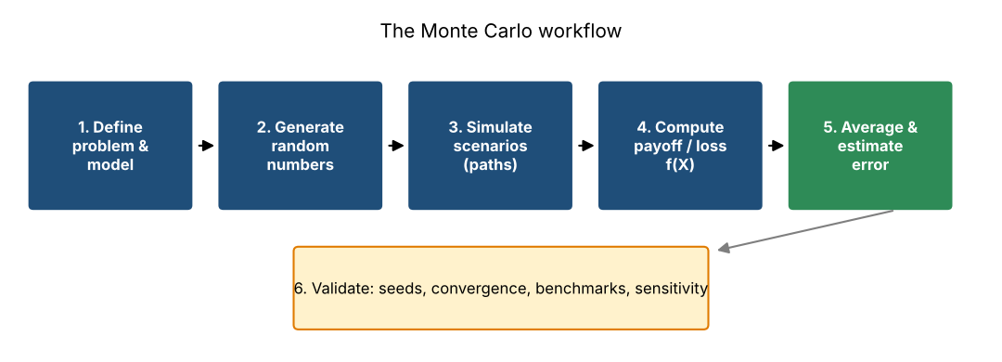
Figure 1. The Monte Carlo workflow. Step 6 (validation) is what separates a trustworthy result from a plausible-looking number.
Reproducibility matters in professional work. All code in this guide uses NumPy's default_rng(seed) generator with a fixed seed so every number can be regenerated exactly. Vectorised operations (drawing and transforming an entire array at once) are used instead of Python loops because they are typically one to two orders of magnitude faster.

3.2 Worked example: an expected value
Problem. Two fair dice are rolled and you receive the larger value. What is the expected payoff? The exact answer is available, so this example lets us check the method. Let f(X) = max(D₁, D₂). Counting outcomes, P(max = k) = (2k − 1)/36, giving E[f] = 161/36 ≈ 4.4722. The simulation draws N = 100,000 pairs of dice:
Python: expected value of the maximum of two dice
rng = np.random.default_rng(42)
N = 100_000
dice = rng.integers(1, 7, size=(N, 2)) # two fair dice
payoff = dice.max(axis=1) # f(X) = larger of the two dice
estimate = payoff.mean()
std_err = payoff.std(ddof=1) / np.sqrt(N)
ci = (estimate - 1.96 * std_err, estimate + 1.96 * std_err)
exact = 161 / 36 # exact E[max] = 4.4722

Output (executed):
estimate = 4.4755 standard error = 0.0044
95% CI = [4.4668, 4.4842] exact = 4.4722

Interpretation. The estimate 4.4755 differs from the exact 4.4722 by 0.0033, which is within one standard error (0.0044), and the 95% confidence interval contains the truth. This is what a healthy simulation looks like: error of the size the standard error predicts. The right-hand panel of Figure 2 shows the simulated distribution of the payoff next to the exact probabilities.

3.3 Estimating π by random sampling
A classic demonstration: throw random points into the unit square. The fraction landing inside the quarter circle x² + y² ≤ 1 estimates the ratio of areas, π/4. Hence π̂ = 4 × (fraction inside). Here f(X) is the indicator that a point falls inside the circle, so θ = π/4 and the estimator is 4θ̂_{N}.
Python: estimating π
rng = np.random.default_rng(42)
N = 100_000
pts = rng.random((N, 2)) # uniform points in the unit square
inside = (pts ** 2).sum(axis=1) <= 1.0 # inside the quarter circle?
pi_hat = 4 * inside.mean()
pi_se = 4 * inside.std(ddof=1) / np.sqrt(N)

Output (executed):
pi_hat = 3.15008 standard error = 0.00517 (true π = 3.14159)

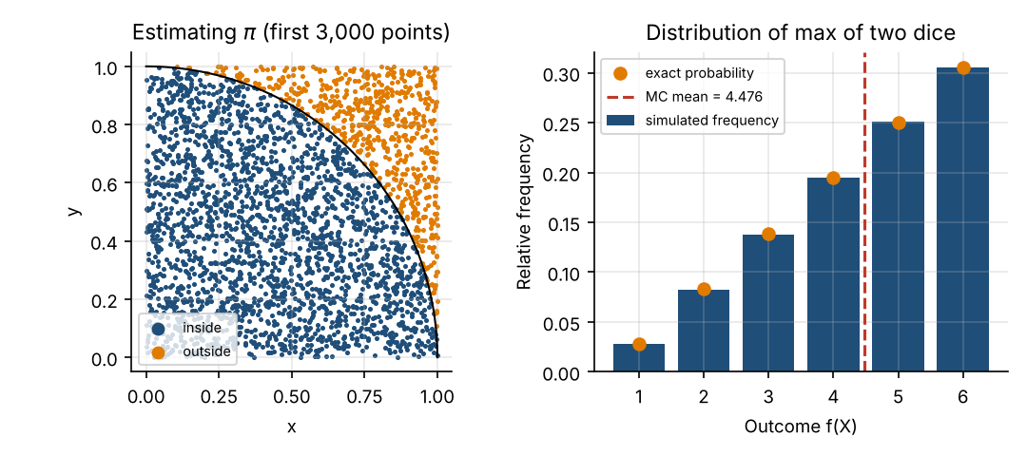
Figure 2. Left: random points used to estimate π (blue = inside the quarter circle). Right: simulated distribution of the larger of two dice against the exact probabilities.

3.4 Seeing the 1/√N law
To confirm the error law empirically we repeat the π estimate 30 times at each sample size from 10² to 10⁶ and measure the root-mean-square (RMS) error against the true value. For this estimator the theoretical standard error is 4√(p(1−p))/√N with p = π/4, i.e. about 1.642/√N.
Python: empirical convergence rate
rng = np.random.default_rng(1)
Ns = np.logspace(2, 6, 13).astype(int)
reps = 30
rms_err = []
for n in Ns:
est = [4 * (rng.random((n, 2)) ** 2).sum(axis=1).__le__(1.0).mean() for _ in range(reps)]
rms_err.append(np.sqrt(np.mean((np.array(est) - np.pi) ** 2)))
theory_se = 4 * np.sqrt((np.pi / 4) * (1 - np.pi / 4)) / np.sqrt(Ns) # exact SE of the estimator
slope = np.polyfit(np.log(Ns), np.log(rms_err), 1)[0]

Table 3. Estimation error for π: measured versus theoretical
N | Measured RMS error | Theoretical SE = 1.642/√N
100 | 0.16326 | 0.16422
1,000 | 0.04117 | 0.05193
10,000 | 0.01445 | 0.01642
100,000 | 0.00577 | 0.00519
1,000,000 | 0.00138 | 0.00164

Fitting a straight line to the log–log data gives a slope of -0.502, essentially the theoretical −0.5 (Figure 3). A hundredfold increase in N, from 10⁴ to 10⁶, reduces the error by roughly a factor of ten, not a hundred.
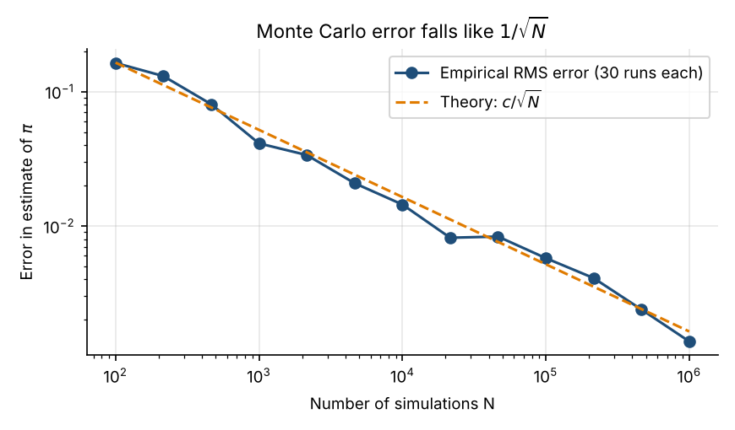
Figure 3. Measured RMS error of the π estimate against N on log–log axes; the dashed line is the theoretical standard error.
Key takeaways
Follow the workflow: model → random numbers → scenarios → payoff → average with SE → validate.
Fix seeds and vectorise. Check against an exact answer whenever one exists, even for a simplified version of the problem.
Empirical convergence plots (error vs N on log–log axes) should show slope ≈ −½; a different slope signals a bug or a dependence problem.

4. Simulating Asset Prices

4.1 Brownian motion
To simulate prices we need a model for how randomness enters over continuous time. Brownian motion (the Wiener process) W_{t} is the basic building block. It has three properties: W₀ = 0; increments over disjoint time intervals are independent; and each increment W_{t+Δt} − W_{t} is normally distributed with mean 0 and variance Δt. Equivalently, an increment can be written √Δt × Z with Z ~ N(0,1), which is exactly how it is generated on a computer. Brownian motion by itself can go negative, so it is not used directly for prices.

4.2 Geometric Brownian Motion
Geometric Brownian Motion (GBM) models the percentage change in a price as a drift plus a random shock. It is the model behind Black–Scholes:
dS_{t} = μ S_{t} dt + σ S_{t} dW_{t} (5)
Here S_{t} is the asset price, μ the drift (the expected rate of return), σ the volatility (the standard deviation of returns per √year) and dW_{t} the Brownian increment. Prices stay positive and returns are independent of price level, two attractive properties. Applying Itô's lemma to ln S_{t} (see Shreve, 2004, or Hull) gives the exact solution, valid for any step size Δt:
S_{t+Δt} = S_{t} · exp[ (μ − ½σ²) Δt + σ √Δt · Z ] , Z ~ N(0,1) (6)
The term −½σ² is the Itô correction. It appears because the exponential of a random variable is convex: without the correction the expected price would grow faster than μ. With it, E[S_{t}] = S₀e^{μt}, while the median price grows more slowly at rate μ − ½σ². Log-returns ln(S_{t+Δt}/S_{t}) are normal with mean (μ − ½σ²)Δt and variance σ²Δt, so prices are lognormal.
Table 4. The roles of the GBM ingredients
Ingredient | Symbol | Role in the simulation | Effect of increasing it
Drift | μ | Average growth of the price; replaced by r under risk-neutral pricing | Shifts the whole distribution of S_{T} upward
Volatility | σ | Scale of the random shocks | Widens the distribution; makes it more right-skewed
Time step | Δt = T/steps | Spacing of observation dates | Irrelevant to accuracy for GBM terminal prices (exact), vital for path-dependent payoffs
Random shock | Z | Independent N(0,1) draw per step and path | Supplies all uncertainty; its quality determines the quality of the result

4.3 Simulating many paths
The function below generates a whole matrix of paths at once. It draws a matrix of standard normals, converts them to log-price increments, accumulates them with a cumulative sum, and exponentiates. Because the GBM transition is exact there is no discretisation error, so even a handful of steps would give the right terminal distribution; many steps are used here only to draw smooth paths and, later, to monitor path-dependent payoffs.
Python: GBM path simulation (S₀=100, μ=8%, σ=20%, T=1, 252 steps, 50,000 paths)
def simulate_gbm(S0, mu, sigma, T, steps, n_paths, rng):
dt = T / steps
Z = rng.standard_normal((n_paths, steps))
log_inc = (mu - 0.5 * sigma ** 2) * dt + sigma * np.sqrt(dt) * Z # exact GBM increments
log_paths = np.cumsum(log_inc, axis=1)
paths = S0 * np.exp(log_paths)
return np.hstack([np.full((n_paths, 1), S0), paths]) # shape (n_paths, steps+1)

rng = np.random.default_rng(7)
S0, mu, sigma, T, steps = 100.0, 0.08, 0.20, 1.0, 252
paths = simulate_gbm(S0, mu, sigma, T, steps, 50_000, rng)
ST = paths[:, -1]
mean_ST, theory_mean = ST.mean(), S0 * np.exp(mu * T)
sd_logret, theory_sd = np.log(ST / S0).std(), sigma * np.sqrt(T)

Output (executed):
mean(S_T) = 108.22 theory S0*exp(mu*T) = 108.33
std of log-return = 0.1993 theory sigma*sqrt(T) = 0.2000
5th / 95th pct of S_T = 76.55 / 147.13

Interpretation. The simulated mean terminal price 108.22 is close to the theoretical 108.33, and the log-return standard deviation 0.1993 matches σ√T = 0.2000. Figure 4 shows the characteristic features: paths fan out over time, the terminal distribution is right-skewed (a few large gains, losses bounded at −100%), and the middle 90% of outcomes spans roughly 77 to 147 for a stock starting at 100.
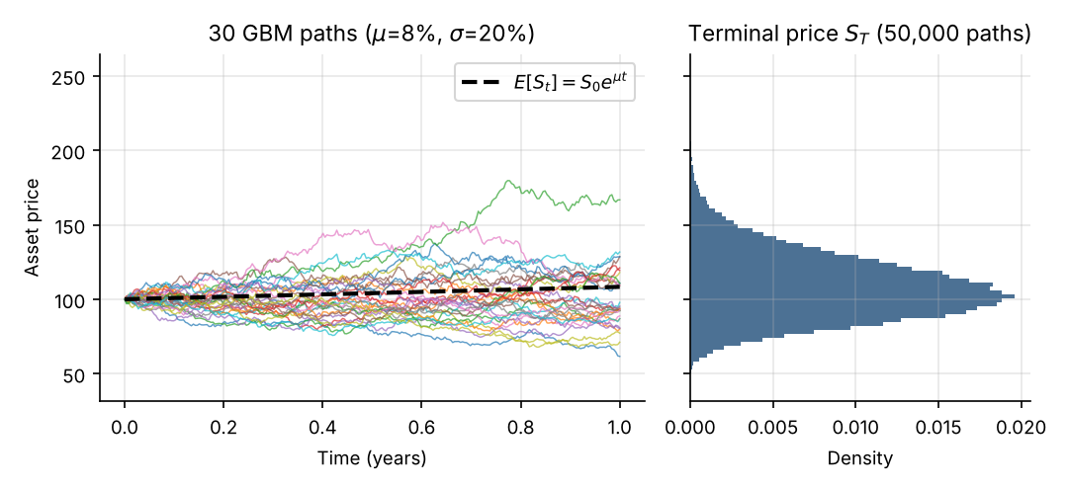
Figure 4. Left: 30 simulated GBM paths with the expected-price curve S₀e^{μt}. Right: histogram of terminal prices across 50,000 paths (shared vertical axis).

4.4 Limitations of GBM
GBM assumes constant volatility, normally distributed log-returns, continuous paths with no jumps, and independent increments. Real markets show volatility clustering, fat tails, jumps around news, and a volatility smile in option prices that constant σ cannot reproduce. GBM remains the standard teaching and benchmarking model because it is tractable and has closed-form option prices to test against; production systems extend it with local or stochastic volatility, jumps, or both.
Key takeaways
Use the exact GBM transition S_{t+Δt} = S_{t}exp[(μ−½σ²)Δt + σ√Δt Z]; do not use the cruder Euler step S_{t}(1 + μΔt + σ√ΔtZ) when the exact one is available.
Forgetting the −½σ² term biases prices upward by an amount that grows with σ and T.
Check your path generator: the mean of S_{T} should be S₀e^{μT} and the standard deviation of ln(S_{T}/S₀) should be σ√T.

5. Monte Carlo Option Pricing

5.1 Risk-neutral valuation
A European call gives the right to buy the asset at strike K at maturity T, so its payoff is (S_{T} − K)⁺ = max(S_{T} − K, 0). A European put pays (K − S_{T})⁺. What is such a contract worth today?
The central result of derivatives pricing is that, in a complete, arbitrage-free market, the price is the discounted expected payoff under a special probability measure Q, the risk-neutral measure, rather than under the real-world measure P:
C₀ = e^{−rT} E^{Q}[ (S_{T} − K)⁺ ] (7)
Under Q the asset's drift is the risk-free rate r, not the real-world expected return μ:
dS_{t} = r S_{t} dt + σ S_{t} dW_{t}^{Q} ⇒ S_{T} = S₀ exp[ (r − ½σ²)T + σ√T Z ] (8)
Why does μ disappear? The option can be hedged by trading the underlying asset continuously, which removes the risk the drift would otherwise be compensating. Once the payoff is replicated by a hedging portfolio, its cost does not depend on investors' appetite for risk, hence not on μ. Under Q every asset earns r on average, which is why this is called risk-neutral: it is a pricing device and does not say investors are risk-neutral or that stocks really grow at r. Only σ, which governs hedging cost, survives. Discounting uses e^{−rT} because under Q the expected payoff is the cost of the replicating portfolio at maturity.

5.2 The Monte Carlo option estimator
Applying the estimator of Section 2.3 to f(S_{T}) = e^{−rT}(S_{T} − K)⁺ gives:
Ĉ₀ = ( e^{−rT} / N ) Σ_{i=1}^{N} max( S_{T}^{(i)} − K , 0 ) (9)
where S_{T}^{(i)} is the i-th simulated terminal price under Q. The standard error is s/√N where s is the sample standard deviation of the discounted payoffs e^{−rT}max(S_{T}^{(i)}−K, 0). Because GBM's terminal price is exact we need only one random draw per path: no time-stepping is required for a European option.
Python: Black–Scholes benchmark and Monte Carlo European pricer
def bs_price(S0, K, r, sigma, T, kind="call"):
d1 = (np.log(S0 / K) + (r + 0.5 * sigma ** 2) * T) / (sigma * np.sqrt(T))
d2 = d1 - sigma * np.sqrt(T)
if kind == "call":
return S0 * norm.cdf(d1) - K * np.exp(-r * T) * norm.cdf(d2)
return K * np.exp(-r * T) * norm.cdf(-d2) - S0 * norm.cdf(-d1)

def mc_european(S0, K, r, sigma, T, N, rng, kind="call"):
Z = rng.standard_normal(N)
ST = S0 * np.exp((r - 0.5 * sigma ** 2) * T + sigma * np.sqrt(T) * Z) # risk-neutral drift r
payoff = np.maximum(ST - K, 0) if kind == "call" else np.maximum(K - ST, 0)
disc = np.exp(-r * T) * payoff
return disc.mean(), disc.std(ddof=1) / np.sqrt(N), disc.std(ddof=1)

S0, K, r, sigma, T = 100.0, 100.0, 0.05, 0.20, 1.0
bs_call, bs_put = bs_price(S0, K, r, sigma, T, "call"), bs_price(S0, K, r, sigma, T, "put")
rows = []
for n in [1_000, 10_000, 100_000, 1_000_000]:
rng = np.random.default_rng(2024)
c, c_se, c_sd = mc_european(S0, K, r, sigma, T, n, rng, "call")
rng = np.random.default_rng(2025)
p, p_se, _ = mc_european(S0, K, r, sigma, T, n, rng, "put")
rows.append(dict(N=n, call=c, call_se=c_se, lo=c - 1.96 * c_se, hi=c + 1.96 * c_se,
err=c - bs_call, put=p, put_se=p_se, payoff_sd=c_sd))
table = pd.DataFrame(rows)

5.3 Worked example versus Black–Scholes
Take S₀ = 100, K = 100, r = 5%, σ = 20%, T = 1 year. The closed-form Black–Scholes values are the theoretical benchmark: call = 10.4506, put = 5.5735. Monte Carlo estimates for increasing N are in Table 5.
Table 5. Monte Carlo call price versus Black–Scholes (theoretical call = 10.4506)
N | MC call | Std. error | 95% CI | Error vs BS | MC put
1,000 | 10.7193 | 0.4859 | [9.767, 11.672] | +0.2687 | 5.6787
10,000 | 10.4369 | 0.1462 | [10.150, 10.723] | -0.0137 | 5.5723
100,000 | 10.4662 | 0.0464 | [10.375, 10.557] | +0.0157 | 5.6224
1,000,000 | 10.4675 | 0.0147 | [10.439, 10.496] | +0.0169 | 5.5802

Interpretation. Three points stand out. (1) Every confidence interval is built from the data alone, yet the Black–Scholes value 10.4506 lies inside the interval at N = 1,000, 10,000 and 100,000; at N = 1,000,000 the estimate 10.4675 is 0.0169 above it, about 1.15 standard errors, which is ordinary sampling variation, and the interval [10.439, 10.496] only just excludes it. A 95% interval will miss the truth about one run in twenty. (2) The standard error falls from 0.486 to 0.015 as N rises a thousandfold, a factor of about 33.0, consistent with √1000 ≈ 31.6. (3) The payoff standard deviation is roughly 14.7, larger than the price itself: option payoffs are highly skewed (many zeros, occasional large values), so many simulations are needed for modest accuracy. Figure 5 shows the convergence.
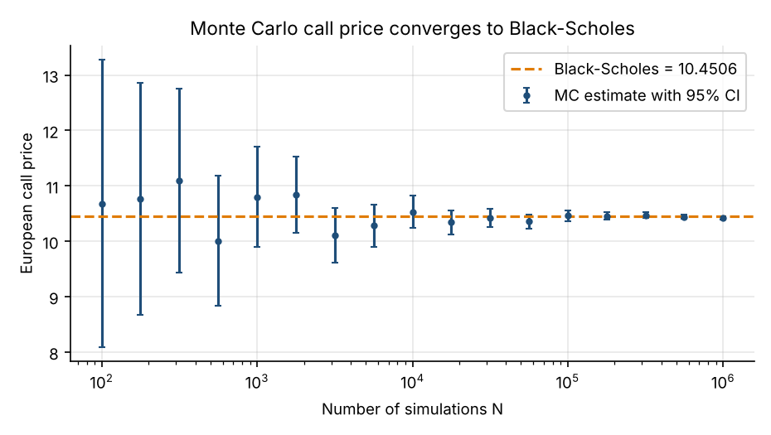
Figure 5. Monte Carlo estimate of the call price (with 95% confidence intervals) as N grows, against the Black–Scholes value (dashed).

5.4 Sensitivity to volatility, maturity and simulation count
A pricer should respond to its inputs the way theory says. We re-price the call over a grid of volatilities (T = 1) and maturities (σ = 20%), using the same standard normal draws for every point (common random numbers) so that differences between points reflect the parameters rather than sampling noise. The largest absolute difference from Black–Scholes over the grid is 0.121 for the volatility sweep and 0.082 for the maturity sweep, with 200,000 draws.
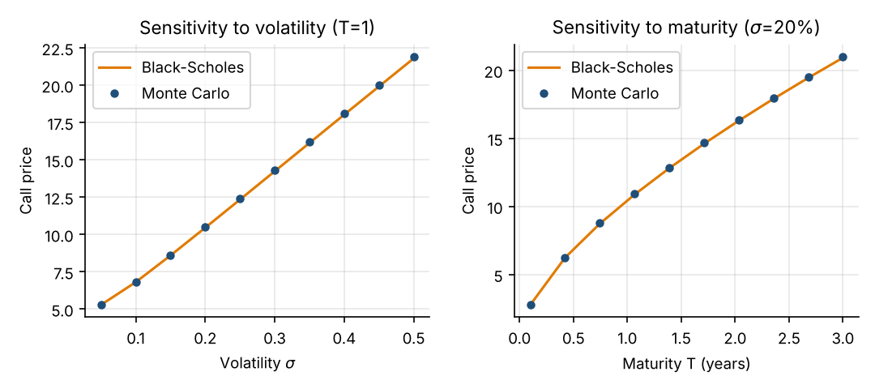
Figure 6. Call price versus volatility (left) and maturity (right): Monte Carlo (dots, 200,000 shared draws) against Black–Scholes (lines).
Table 6. How the at-the-money call price responds to its inputs (Monte Carlo, common random numbers)
Input changed | Range | Call price range | Intuition
Volatility σ | 5% → 50% | 5.29 → 21.91 | More dispersion raises the value of the option’s one-sided payoff
Maturity T | 0.1 → 3 years | 2.78 → 21.01 | More time means more dispersion and more interest carry
Simulations N | 10³ → 10⁶ | Accuracy only | Standard error falls as 1/√N; the price itself does not change systematically

Key takeaways
Price with the risk-free rate r as drift and discount at r. Real-world μ never enters the price.
Always output the standard error or confidence interval beside the price.
Use common random numbers when comparing prices across parameters (and for stable finite-difference Greeks).

Common mistakes
Simulating with the real-world drift μ and then discounting at r (mixing measures).
Discounting by e^{−rT} twice, or not at all; or averaging the payoff before taking the max(·,0).
Pricing a put with a call formula and sign error in the payoff.

6. Variance Reduction
Since error = σ_{f}/√N, we can improve accuracy either by raising N or by lowering the variance of the quantity being averaged. Variance reduction methods do the second, keeping the estimator unbiased (or nearly so) while shrinking its standard error. The comparison below is fair in the sense that every method uses the same budget of N = 8,192 payoff evaluations per estimate, and each estimate is repeated 400 times so its spread can be measured directly.

6.1 Antithetic variates
Intuition. For every random draw Z also use −Z. A path that ends high is paired with one that ends low; their payoffs are negatively correlated for a monotonic payoff, so the pair’s average has lower variance. Formula: Ĉ_{anti} = (1/N) Σ ½[ f(Z_{i}) + f(−Z_{i}) ]. Benefit: trivial to implement and costs almost nothing. Limitation: the gain depends on the payoff being roughly monotonic in Z; for payoffs symmetric in Z (a straddle) it can even hurt.

6.2 Control variates
Intuition. Find a quantity Y, correlated with the payoff X, whose true expectation is known. Whatever error the simulation makes on Y tells us about the error on X, which we can correct. Formula: X^{cv} = X − β( Y − E[Y] ) with the variance-minimising β = Cov(X, Y)/Var(Y); the variance is reduced by the factor (1 − ρ²) where ρ is the correlation of X and Y. Here Y = S_{T}, whose risk-neutral mean S₀e^{rT} is known exactly. Limitation: requires a good correlated control with known mean; β is estimated from the same sample, creating a small bias that vanishes as N grows.

6.3 Importance sampling
Intuition. Rare but important events (a deep out-of-the-money option finishing in the money) are seldom sampled. Draw from a different distribution that visits them often, and correct with a likelihood ratio. For a normal shock, shifting the mean to θ gives weights w(y) = exp(−θy + ½θ²), so E[f(Z)] = E[f(Y)w(Y)] with Y ~ N(θ, 1). Benefit: massive gains for rare-event problems such as far-out-of-the-money options and tail-risk estimation. Limitation: a badly chosen shift can raise variance or make it infinite; it needs problem-specific tuning.

6.4 Quasi-Monte Carlo
Intuition. Pseudo-random points clump and leave gaps. Low-discrepancy sequences (Sobol, Halton) fill the space evenly, giving error that can approach 1/N rather than 1/√N for smooth, low-dimensional problems. Randomised (scrambled) versions allow a standard error to be measured by repeating with different scrambles. Limitation: the advantage fades as dimension grows or when the payoff is discontinuous, and results are not independent draws, so the ordinary SE formula does not apply to a single run.
Python: five estimators of the call price and the repeated-estimate experiment
def estimate_once(method, N, rng, K=100.0):
drift, vol = (r - 0.5 * sigma ** 2) * T, sigma * np.sqrt(T)
disc = np.exp(-r * T)
if method == "plain":
ST = S0 * np.exp(drift + vol * rng.standard_normal(N))
return disc * np.maximum(ST - K, 0).mean()
if method == "antithetic":
Z = rng.standard_normal(N // 2)
pay = 0.5 * (np.maximum(S0 * np.exp(drift + vol * Z) - K, 0) + np.maximum(S0 * np.exp(drift - vol * Z) - K, 0))
return disc * pay.mean()
if method == "control": # control variate: S_T has known mean S0*exp(rT)
ST = S0 * np.exp(drift + vol * rng.standard_normal(N))
X, Y = disc * np.maximum(ST - K, 0), ST
beta = np.cov(X, Y)[0, 1] / Y.var(ddof=1)
return (X - beta * (Y - S0 * np.exp(r * T))).mean()
if method == "sobol": # scrambled Sobol quasi-random points
u = qmc.Sobol(d=1, scramble=True, seed=rng.integers(1 << 31)).random(N)
ST = S0 * np.exp(drift + vol * norm.ppf(u[:, 0]))
return disc * np.maximum(ST - K, 0).mean()
if method == "importance": # shift the normal mean to theta so OTM payoffs are sampled often
theta = (np.log(K / S0) - drift) / vol
Y = rng.standard_normal(N) + theta
weight = np.exp(-theta * Y + 0.5 * theta ** 2) # likelihood ratio dN(0,1)/dN(theta,1)
return disc * (np.maximum(S0 * np.exp(drift + vol * Y) - K, 0) * weight).mean()

Nvr, reps = 8192, 400
vr = {}
for kk, methods in [(100.0, ["plain", "antithetic", "control", "sobol"]), (140.0, ["plain", "importance"])]:
for mth in methods:
rng = np.random.default_rng(11)
ests = np.array([estimate_once(mth, Nvr, rng, kk) for _ in range(reps)])
vr[(kk, mth)] = (ests.mean(), ests.std(ddof=1))

Table 7. Variance reduction results (N = 8,192 per estimate, 400 repeats; theoretical price 10.4506 for K = 100, 0.7850 for K = 140)
Method | Strike | Mean of estimates | Std. dev. of estimate | Variance reduction factor | Best used when
Plain MC | 100 | 10.4653 | 0.1644 | 1× | Baseline; non-smooth, high-dimensional problems
Antithetic | 100 | 10.4532 | 0.1138 | 2.1× | Monotonic payoffs; a free first step
Control variate | 100 | 10.4523 | 0.0628 | 6.9× | A correlated instrument with known price exists
Sobol (QMC) | 100 | 10.4505 | 0.00133 | 15,389× | Smooth payoffs, low to moderate dimension
Plain MC | 140 | 0.7874 | 0.0470 | 1× | —
Importance sampling | 140 | 0.7851 | 0.0098 | 22.9× | Rare-event, deep out-of-the-money, tail estimation

Interpretation. All five methods are unbiased in practice: their mean estimates (10.453–10.465) agree with the theoretical 10.451 within noise, and the importance-sampling mean 0.7851 matches 0.7850. What changes is the spread (Figure 7). Antithetic variates cut the variance by 2.1×, a control variate by 6.9×, and scrambled Sobol points by a factor in the thousands for this smooth one-dimensional problem. Importance sampling cuts the variance of the out-of-the-money call by 22.9×. The Sobol result is exceptional because the problem has only one random dimension; do not expect such gains for a 252-step path or a 50-asset portfolio.
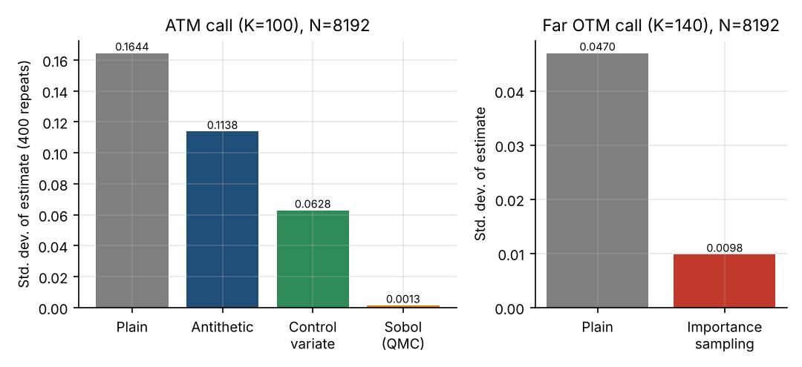
Figure 7. Standard deviation of the call-price estimate under different methods (lower is better). Left: at-the-money call; right: far out-of-the-money call (K = 140).
Table 8. Summary comparison of variance-reduction techniques
Technique | Idea | Typical gain | Cost / risk
Antithetic variates | Pair Z with −Z | Modest (≈ 1.5–3×) | Almost none; can hurt for symmetric payoffs
Control variates | Subtract a correlated variable with known mean | Large when ρ is high | Needs a good control; small estimated-β bias
Importance sampling | Sample the important region more often; reweight | Very large for rare events | Needs tuning; can increase variance
Quasi-Monte Carlo | Evenly spread low-discrepancy points | Very large for smooth, low-dimension problems | Weaker in high dimension / discontinuities; SE needs randomisation

Key takeaways
Variance reduction is equivalent to free simulations: a 10× variance cut equals 10× more paths.
Always verify that a variance-reduced estimator is still unbiased by checking it against a known answer.
Combine methods where possible (for example antithetic + control variate), but measure each addition.

7. Portfolio Risk Management

7.1 Simulating correlated returns
A portfolio contains several assets whose returns move together. To simulate this we need draws with a prescribed covariance matrix Σ, whose entries are Σ_{ij} = σ_{i}σ_{j}ρ_{ij}, with ρ_{ij} the correlation between assets i and j. The standard tool is the Cholesky decomposition: any symmetric positive-definite matrix can be factored as Σ = L L^{T} with L lower-triangular. If z is a vector of independent N(0,1) draws, then
r = μΔt + L z where L L^{T} = Σ Δt ⇒ Cov(r) = ΣΔt (10)
has exactly the required covariance. Intuitively, L “mixes” independent shocks so that asset j partly shares the shock driving asset i. In code, a single matrix product z @ L.T produces all correlated returns for all simulations at once.

7.2 Value at Risk and Expected Shortfall
Throughout this guide we use a positive-loss convention: the loss is L = −(change in portfolio value), so a large positive L is bad. For a confidence level α (such as 99%) over a stated horizon:
VaR_{α} = inf { ℓ : P(L ≤ ℓ) ≥ α } ES_{α} = E[ L | L ≥ VaR_{α} ] (11)
VaR is the loss threshold that is exceeded only with probability 1 − α: a 99% 10-day VaR of $70,000 means that losses larger than $70,000 are expected on about 1 day in 100 ten-day windows. Expected Shortfall (also called conditional VaR) is the average loss on those worst (1 − α) outcomes. VaR says where the tail begins; ES says how bad it is once inside. ES is “coherent” (it respects diversification, which VaR can violate; see Artzner et al., 1999) and is used for market-risk capital under Basel's Fundamental Review of the Trading Book at the 97.5% level.

7.3 Worked example: four-asset portfolio
A portfolio of $1,000,000 is held in Equity A ($400k), Equity B ($300k), a Bond ETF ($200k) and a Commodity position ($100k). Annual expected returns are 8%, 7%, 3% and 5%; annual volatilities 25%, 20%, 8% and 30%. The equities are strongly positively correlated (0.60), the bond is slightly negatively correlated with equities, and the commodity has modest positive correlation (0.30 and 0.25) with the equities. The horizon is 10 trading days (h = 10/252).
Table 9. Portfolio inputs
Asset | Value ($) | Expected return | Volatility | ρ with A | ρ with B | ρ with Bond
Equity A | 400,000 | 8% | 25% | 1.00 | 0.60 | −0.10
Equity B | 300,000 | 7% | 20% | 0.60 | 1.00 | −0.05
Bond ETF | 200,000 | 3% | 8% | −0.10 | −0.05 | 1.00
Commodity | 100,000 | 5% | 30% | 0.30 | 0.25 | 0.00

Python: correlated simulation, VaR and ES
rng = np.random.default_rng(123)
assets = ["Equity A", "Equity B", "Bond ETF", "Commodity"]
value = np.array([400_000, 300_000, 200_000, 100_000.0]) # position values, total 1,000,000
mu_a = np.array([0.08, 0.07, 0.03, 0.05]) # annual expected returns
vol_a = np.array([0.25, 0.20, 0.08, 0.30]) # annual volatilities
corr = np.array([[1.00, 0.60, -0.10, 0.30],
[0.60, 1.00, -0.05, 0.25],
[-0.10, -0.05, 1.00, 0.00],
[0.30, 0.25, 0.00, 1.00]])
h = 10 / 252 # 10-trading-day horizon
cov = np.outer(vol_a, vol_a) * corr
L = np.linalg.cholesky(cov * h) # cov*h = L L^T
n_sims, alpha = 200_000, 0.99

def var_es(loss, alpha):
var = np.quantile(loss, alpha)
return var, loss[loss >= var].mean() # positive-loss convention

def portfolio_loss(L, z):
returns = mu_a * h + z @ L.T # correlated simple returns
return -(returns @ value) # loss = -P&L

z = rng.standard_normal((n_sims, 4))
loss = portfolio_loss(L, z)
var99, es99 = var_es(loss, alpha)
sd_p = np.sqrt(value @ (cov * h) @ value)
var_normal = -(mu_a * h) @ value + norm.ppf(alpha) * sd_p # analytic Gaussian VaR
es_normal = -(mu_a * h) @ value + sd_p * norm.pdf(norm.ppf(alpha)) / (1 - alpha)
L0 = np.linalg.cholesky(np.diag(vol_a ** 2) * h) # zero-correlation comparison
var_uncorr, es_uncorr = var_es(portfolio_loss(L0, rng.standard_normal((n_sims, 4))), alpha)
nu = 4 # fat tails: multivariate t, same covariance
w = rng.chisquare(nu, size=(n_sims, 1)) / nu
z_t = rng.standard_normal((n_sims, 4)) / np.sqrt(w) * np.sqrt((nu - 2) / nu)
var_t, es_t = var_es(portfolio_loss(L, z_t), alpha)

Output (executed):
simulations = 200,000 portfolio 10-day std dev = $31,015
99% VaR = $69,135 99% ES = $79,709 mean loss = $-2,595 (an expected gain)

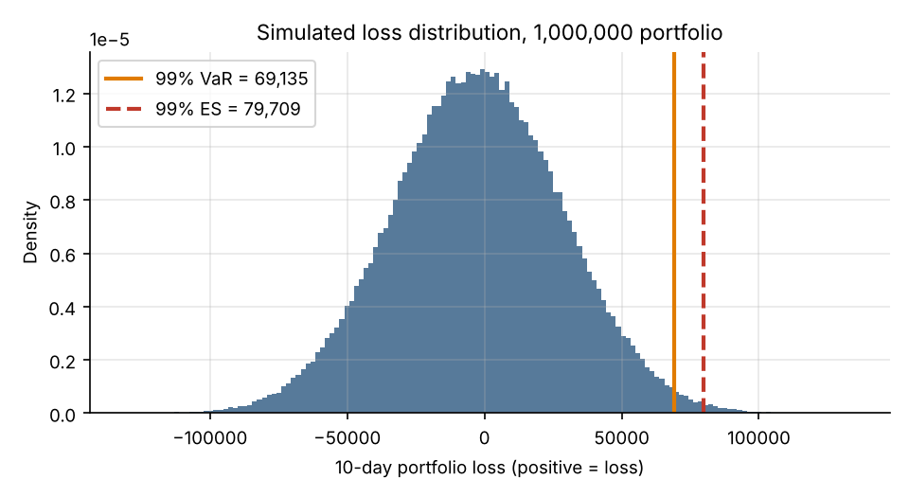
Figure 8. Simulated 10-day loss distribution for the $1,000,000 portfolio with 99% VaR and Expected Shortfall marked (positive = loss).
Interpretation (Figure 8). The 99% 10-day VaR is $69,135 (6.9% of portfolio value) and the 99% ES is $79,709 (8.0%), about 1.15 times VaR. The mean loss is negative (an expected gain of about $2,595) because of the positive drift over ten days. The Monte Carlo VaR is within 0.7% of the analytic normal VaR (69,611), as it should be, since the inputs are jointly normal; the residual gap is sampling noise in a tail quantile estimated from the worst 2,000 of 200,000 draws.

7.4 Correlation, tail risk and model limitations
Two experiments with the same code show why assumptions matter (Table 10). First, remove correlation (set all ρ = 0): VaR drops by 22% relative to the correlated base case. The diversification benefit looks bigger than it is, so ignoring correlation understates risk. Second, keep the same means, volatilities and correlations but draw shocks from a multivariate Student-t distribution with 4 degrees of freedom, scaled to the same covariance. VaR rises by 15% and ES by 40%. The two models have identical variances yet very different tails: fat tails matter most for ES and for the highest confidence levels.
Table 10. Sensitivity of 99% 10-day risk measures to modelling assumptions ($)
Model | VaR | ES | Comment
Correlated normal (base) | 69,135 | 79,709 | Simulated; analytic normal VaR 69,611, ES 80,121
Uncorrelated normal | 53,731 | 61,996 | Overstates diversification
Correlated Student-t (ν = 4) | 79,289 | 111,661 | Same covariance, fatter tails

Other limitations: correlations are not constant and tend to rise in crises, precisely when diversification is needed; the example uses simple returns with a linear (delta-one) portfolio, whereas options require full revaluation or Greeks-based approximations in each scenario; and a 10-day horizon is assumed to scale from daily volatility by √time with no liquidity cost of exiting positions. VaR is also backward-looking if its inputs are estimated from history, and tail quantiles at 99.9% need far more simulations than at 95% because few draws fall beyond the threshold.
Key takeaways
Cholesky decomposition converts independent normals into correlated returns; always check that the sample correlation of your output matches the input.
Use a consistent positive-loss convention. VaR is a quantile, ES an average beyond it.
Risk numbers inherit the assumptions of the distribution: correlation and tail-shape choices can move them by tens of percent.

8. Path-Dependent Derivatives

8.1 Why full paths are needed
A European option depends only on the terminal price S_{T}, which GBM provides in one step. Many contracts depend on what happens along the way, so the whole path S_{t_1}, …, S_{t_M} must be simulated at the monitoring dates. This is where Monte Carlo becomes indispensable: closed-form formulas are rare, and lattice or PDE methods struggle as the path-dependence adds state variables.
Table 11. Common path-dependent options (payoffs for a call)
Contract | Payoff | Depends on | Intuition
Asian (average price) | max( S̄ − K , 0 ), S̄ = (1/M) Σ S_{t_j} | Average price | Averaging smooths price; cheaper than European; resists manipulation of the closing price
Barrier (down-and-out) | max( S_{T} − K , 0 ) × 1{ min S_{t} > H } | Whether a barrier H is hit | Cheaper than European because it can be knocked out; sensitive to monitoring frequency
Lookback (fixed strike) | max( max S_{t} − K , 0 ) | Maximum price | Pays for the best level reached; very expensive

8.2 Worked example: arithmetic-average Asian call
An arithmetic Asian call pays max(S̄ − K, 0) where S̄ is the average of the 252 daily closing prices over one year. There is no simple closed form for the arithmetic average, which is why simulation is the standard approach. We use the risk-neutral paths (drift r) and the same inputs as before (S₀=K=100, r=5%, σ=20%, T=1) with N = 200,000 paths. The European call is computed on the same paths for a like-for-like comparison.
Python: pricing an Asian call by simulating complete paths
rng = np.random.default_rng(2026)
S0, K, r, sigma, T, steps, N = 100.0, 100.0, 0.05, 0.20, 1.0, 252, 200_000
paths = simulate_gbm(S0, r, sigma, T, steps, N, rng) # risk-neutral: mu = r
avg_price = paths[:, 1:].mean(axis=1) # arithmetic average of daily prices
asian_disc = np.exp(-r * T) * np.maximum(avg_price - K, 0)
asian_price, asian_se = asian_disc.mean(), asian_disc.std(ddof=1) / np.sqrt(N)
euro_disc = np.exp(-r * T) * np.maximum(paths[:, -1] - K, 0) # European call on the same paths
euro_price, euro_se = euro_disc.mean(), euro_disc.std(ddof=1) / np.sqrt(N)

Output (executed):
Asian call = 5.7859 standard error = 0.0179
European call = 10.4784 standard error = 0.0329 (Black-Scholes 10.4506)

Interpretation. The Asian call is worth 5.786 against 10.478 for the European, about 55% as much. Averaging reduces the effective volatility of the payoff variable (the average of a path moves less than its endpoint), and an option on a less volatile quantity is cheaper. The payoff standard deviation is also about 0.54 times that of the European, so the Asian price is estimated more precisely for the same N. The European estimate 10.478 is within 0.8 standard errors of the exact 10.451, validating the path generator. Figure 9 illustrates how the running average (dashed) is much smoother than the price.
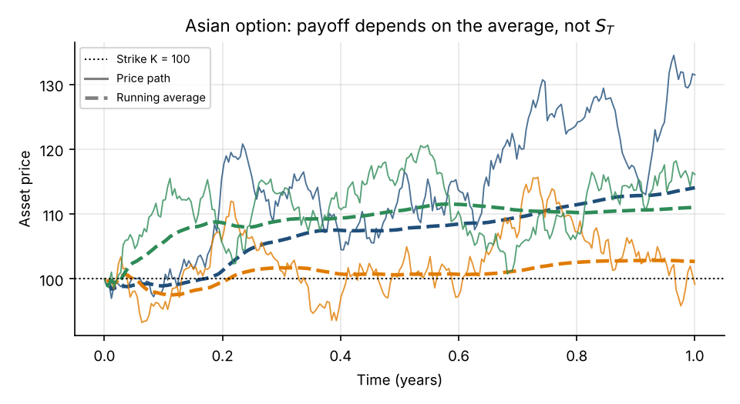
Figure 9. Three simulated risk-neutral price paths (solid) and their running averages (dashed). The Asian payoff uses the final average, not the final price.

8.3 Barrier and lookback options, and monitoring bias
Using risk-neutral paths with the same parameters (N = 200,000, daily monitoring), a down-and-out call with barrier H = 90 is worth 8.934 (SE 0.033), cheaper than the European call because some paths are knocked out. A fixed-strike lookback call, which pays for the highest price reached, is worth 18.391 (SE 0.034), far more than the European call. The ordering Asian < barrier < European < lookback in Table 12 follows from the payoff definitions.
Table 12. Prices of one-year at-the-money calls on the same risk-neutral paths (S₀ = K = 100, r = 5%, σ = 20%)
Contract | MC price | Std. error | Note
Asian (arithmetic, daily) | 5.801 | 0.018 | Averaging lowers value
Down-and-out call (H = 90, daily monitoring) | 8.934 | 0.033 | Knock-out lowers value
European call | 10.483 | 0.033 | Black–Scholes: 10.451
Lookback call (fixed strike) | 18.391 | 0.034 | Best-price payoff raises value

Monitoring bias. Simulation checks the barrier only at discrete dates, but a contract that monitors continuously can be knocked out between them. Re-pricing the barrier option with weekly instead of daily monitoring (52 steps) gives 9.155 against 8.934, a difference of 0.220, many standard errors. Fewer monitoring dates means fewer chances to be knocked out and therefore a higher price. For barrier and lookback options the time-step choice is not innocuous even though the GBM step is exact.

8.4 American options and least-squares Monte Carlo
An American option may be exercised at any time, so its value requires an optimal stopping decision: at each date, exercise if the immediate payoff exceeds the value of continuing. Monte Carlo seems ill-suited because simulated paths run forward, while the decision needs future information. The Longstaff–Schwartz least-squares Monte Carlo (LSM) algorithm solves this by working backward: at each exercise date, regress the discounted future cash flows of the in-the-money paths on a polynomial of the current price, using the fitted curve as an estimate of the continuation value; exercise where the intrinsic value exceeds it.
Python: least-squares Monte Carlo for an American put (extra.py)
def lsm_put(S0,K,r,sigma,T,steps,N,seed,deg=2):
rng=np.random.default_rng(seed); dt=T/steps
p=simulate_gbm(S0,r,sigma,T,steps,N,rng)
cash=np.maximum(K-p[:,-1],0)
for t in range(steps-1,0,-1):
cash*=np.exp(-r*dt)
itm=K-p[:,t]>0
if itm.sum()>deg+1:
coef=np.polyfit(p[itm,t],cash[itm],deg)
cont=np.polyval(coef,p[itm,t]); ex=K-p[itm,t]
idx=np.where(itm)[0][ex>cont]
cash[idx]=ex[ex>cont]
return float(np.exp(-r*dt)*cash.mean()), float(np.exp(-r*dt)*cash.std(ddof=1)/np.sqrt(N))

For a one-year at-the-money put (S₀=K=100, r=5%, σ=20%) with 50 exercise dates and 100,000 paths, LSM gives 6.071 (SE 0.022). A 1,000-step binomial tree gives 6.090 for the American put and 5.572 for the European put (Black–Scholes 5.574). LSM is slightly low, as expected: a regression-based exercise rule is a feasible, hence suboptimal, strategy, and fewer exercise dates than continuous exercise also lowers the value. The early-exercise premium of roughly 0.52 is the extra value from the right to exercise early, which matters for puts because the interest earned on the strike makes early exercise attractive.
Key takeaways
Use full paths when the payoff depends on average, extremum or barrier crossing; use the exact GBM step to avoid discretisation error in the path, but remember discrete monitoring still differs from continuous monitoring.
Always validate a path simulator by repricing the European option on the same paths.
LSM estimates a lower bound on the American price because the exercise rule is approximate.

9. Limitations and Practical Pitfalls

9.1 Sampling error, bias and model risk
It is essential to separate three different sources of error. Sampling error (variance) is the random scatter from using finite N; it is measured by the standard error and shrinks with N. Bias (discretisation error) is a systematic deviation of the expected estimator from the model's true value, as when a continuously-monitored barrier is checked daily or an SDE is approximated by Euler steps; it does not shrink with N, only with finer time steps. Model risk (misspecification) is the possibility that the model itself is wrong (constant volatility, no jumps, normal tails), so that even a perfect simulation answers the wrong question. A tiny confidence interval says nothing about the latter two.
Table 13. Variance, bias and model misspecification compared
Source | Cause | Reduced by | Detected by
Sampling error (variance) | Finite N | More paths; variance reduction | Standard error; repeat with new seeds
Bias / discretisation | Approximating continuous time or the SDE; imperfect exercise rule | Finer steps; exact schemes; extrapolation | Convergence study in step size; benchmark
Model misspecification | Wrong dynamics, parameters or measure | Better model; calibration; stress tests | Backtesting; comparison with market prices; alternative models

9.2 Frequent implementation errors
- Too few simulations. Quantiles in the tail (99.9% VaR) need much larger N than means; check the stability of the estimate across seeds.
- Incorrect discounting. Discount payoffs from the payment date to today at the risk-free (or appropriate funding) rate, once. Pricing and risk simulations use different conventions: pricing discounts, VaR usually does not.
- Wrong probability measure. Use the risk-neutral measure (drift r) for pricing and the real-world measure (drift μ) for risk and scenario analysis. Mixing them is the single most common conceptual error.
- Correlation errors. A non-positive-definite matrix (from inconsistent pairwise estimates) makes Cholesky fail; sample correlations must be checked against the target; correlation is not constant across regimes.
- Discretisation error. Euler steps are biased for large Δt; use exact transitions where available and check convergence in Δt for path-dependent payoffs.
- Random-number mistakes. Reusing a seed across “independent” runs, correlating draws accidentally, or forgetting that quasi-random points are not independent.

9.3 Unrealistic assumptions in trading applications
When simulation is used to evaluate trading strategies or hedges, results are only as realistic as the market dynamics assumed. Fat tails and jumps make extreme moves far more frequent than GBM allows; a strategy that looks safe under normal returns can fail under a Student-t or jump-diffusion. Transaction costs, slippage and market impact are usually omitted in simple simulations but can erase an apparent edge, especially for frequently rebalanced hedges. Volatility is not constant, and ignoring clustering understates the probability of consecutive large losses. Parameter uncertainty: drift and correlation are hard to estimate, and treating estimates as known inflates confidence. Good practice is to repeat the analysis under alternative models and stressed parameters and report the range.
Common mistakes
Reporting a price to six decimals when the standard error is in the second decimal.
Tuning the model until the simulation “matches” the market, then trusting its predictions out of sample.
Believing that more simulations can fix a wrong model.

Key takeaways
Distinguish variance (shrinks with N), bias (shrinks with finer steps) and model risk (shrinks only with a better model).
Match the measure to the purpose: Q for prices, P for risk.
Validate with analytic benchmarks, convergence tests, multiple seeds and stress scenarios.

10. Integrated Case Study and Interview Revision

10.1 Case study: pricing an option and assessing downside risk
A desk holds the $1,000,000 portfolio from Chapter 7 and has bought 4,000 one-year at-the-money puts (S₀=K=100) as protection for its 4,000-share Equity A position. The questions are: (a) what are the puts worth, and (b) how much could the portfolio lose over ten days? The same toolkit answers both, but with different measures and purposes.
Table 14. Case-study workflow
Step | Pricing the puts | Assessing the portfolio
1. Model assumptions | GBM, constant σ = 20%, r = 5%, no dividends | Joint normal 10-day returns; given covariance; linear positions
2. Probability measure | Risk-neutral Q: drift r | Real-world P: drift μ
3. Implementation | Simulate S_{T} (exact); discounted payoff; Section 5.2 | Cholesky; loss = −P&L; quantile and tail average; Section 7.3
4. Accuracy | N = 10⁶: SE 0.0087; variance reduction as in Table 7 could cut the error further | N = 200,000; tail from worst 2,000 draws
5. Validation | Black–Scholes put 5.5735; put–call parity; convergence plot | Analytic normal VaR 69,611; sample correlation check
6. Sensitivity | σ, T sweeps (Figure 6); common random numbers | No correlation, fat tails (Table 10)
7. Result | MC put 5.580 ± 0.017; premium for 4,000 puts ≈ $22,321 | 99% 10-day VaR $69,135, ES $79,709; Student-t ES $111,661

Interpretation
The puts cost about $22,321 in premium, around 2.2% of the portfolio, a modest insurance cost. The risk figures describe the unhedged linear portfolio; adding the options would require revaluing them in each scenario (a non-linear position), which would reduce the loss on large Equity A declines. The honest summary is: the baseline model gives a 99% 10-day VaR of about 7% of capital, but under fatter tails the same covariance gives ES nearly 1.4 times larger, so the capital buffer should be set on the more conservative view. Remember also that Q and P are used for different jobs: the option price must not depend on the equity’s expected return, while the portfolio risk measure must.

10.2 Ten interview questions with answers
Q1. What is Monte Carlo simulation and why is it used in finance?
A. It estimates an expected value by averaging many random simulated outcomes. It is used when closed forms do not exist (path-dependent options, many risk factors, complex portfolios) because its error rate 1/√N does not depend on the problem’s dimension.
Q2. Why does the Monte Carlo error decrease as 1/√N?
A. The estimator is an average of N independent outcomes, so its variance is σ_{f}²/N and its standard error σ_{f}/√N. Halving the error needs four times the simulations.
Q3. Explain the difference between the real-world and risk-neutral measures.
A. Under P assets grow at their real expected returns μ and are used for risk and forecasting. Under Q every traded asset has drift r and discounted prices are martingales; it is used for pricing because hedging removes risk-premium dependence. Volatility is unchanged between the two.
Q4. Why is there a −½σ² term in the GBM solution?
A. It is the Itô correction. Since E[e^{σW_{t}}] = e^{σ^{2}t/2}, subtracting ½σ²t from the exponent makes E[S_{t}] = S₀e^{μt}. The median grows at μ − ½σ².
Q5. How do you obtain a confidence interval for a simulated option price?
A. Compute the sample mean and sample standard deviation s of the discounted payoffs; the standard error is s/√N and the 95% interval is mean ± 1.96 × SE (CLT).
Q6. Name and explain two variance-reduction techniques.
A. Antithetic variates pair Z with −Z to induce negative correlation between payoffs. A control variate subtracts β(Y − E[Y]) for a correlated Y with known mean, reducing variance by the factor 1 − ρ². (Importance sampling and QMC are alternatives.)
Q7. Define VaR and Expected Shortfall. Which is better and why?
A. With loss L, VaR_{α} is the α-quantile of L; ES_{α} = E[L | L ≥ VaR_{α}]. ES is sub-additive (coherent) and informs about tail severity, so it is preferred in regulation (97.5% ES under FRTB). VaR is easier to back-test.
Q8. How do you simulate correlated assets?
A. Factor the covariance as Σ = LL^{T} (Cholesky), draw independent standard normals z, and form returns μΔt + Lz, where L is the Cholesky factor of the horizon covariance ΣΔt.
Q9. Why can a discretely monitored barrier option be mispriced by simulation?
A. The simulation can miss a crossing between monitoring dates, so a continuously monitored option is knocked out more often than the simulation suggests. The price is biased upward; the bias shrinks with more time steps or with a continuity correction.
Q10. Why can’t American options be priced by simple forward simulation?
A. The optimal exercise decision depends on the continuation value, which depends on the future. LSM solves backward, estimating the continuation value by regression on simulated paths, and produces a lower bound.

10.3 Five numerical and coding questions
N1. How many simulations are needed for a call-price standard error of 0.01, given a discounted-payoff standard deviation of about 14.7?
A. N = (s/SE)² = (14.7/0.01)² ≈ 2.17 million. For a 95% interval of half-width 0.01 use 1.96 s/√N = 0.01, giving N ≈ 8.3 million.
N2. How many points are needed to estimate π with a standard error of 0.001?
A. The per-point standard deviation is 4√(p(1−p)) with p = π/4, ≈ 1.642. N = (1.642/0.001)² ≈ 2.70 million, because 1.642/√N = 0.001.
N3. Under the risk-neutral measure (S₀=100, r=5%, σ=20%, T=1, no dividends), what is P(S_{T} > 100)? Verify by simulation.
A. P(S_{T} > K) = N(d₂) with d₂ = (r − ½σ²)T/(σ√T) = 0.15, so N(0.15) = 0.5596. Simulating 1,000,000 draws (seed 8) gave 0.5603. Note this is not the same as the real-world probability, which uses μ in place of r.
N4. Check put–call parity by simulation (same inputs).
A. C − P = S₀ − Ke^{−rT} = 4.8771. Using the same simulated S_{T}, the discounted call mean minus the discounted put mean was 4.8910; the gap of 0.014 is sampling noise. In code: np.exp(-r*T)*(np.maximum(ST-K,0)-np.maximum(K-ST,0)).mean().
N5. Real-world μ = 8%, σ = 20%: estimate P(S₁ < 80) starting from 100. Give the exact value.
A. ln(80/100) = −0.2231; the log-return has mean μ − ½σ² = 0.06 and sd 0.20, so z = (−0.2231 − 0.06)/0.20 = −1.416 and P = N(−1.416) = 0.0784. A simulation with 1,000,000 draws (seed 31) gave 0.0786. In code: (100*np.exp(0.06+0.2*rng.standard_normal(10**6))<80).mean().

10.4 Formula sheet
Table 15. Key formulas
Quantity | Formula
Monte Carlo estimator | θ̂_{N} = (1/N) Σ f(X_{i})
Standard error / 95% CI | SE ≈ s/√N ; θ̂_{N} ± 1.96 SE
GBM SDE | dS_{t} = μS_{t}dt + σS_{t}dW_{t}
Exact GBM step | S_{t+Δt} = S_{t}exp[(μ − ½σ²)Δt + σ√Δt Z]
Risk-neutral terminal price | S_{T} = S₀exp[(r − ½σ²)T + σ√T Z]
European call (risk-neutral) | C₀ = e^{−rT}E^{Q}[(S_{T} − K)⁺]
MC call estimator | Ĉ₀ = (e^{−rT}/N) Σ max(S_{T}^{(i)} − K, 0)
Black–Scholes call | C = S₀N(d₁) − Ke^{−rT}N(d₂); d_{1,2} = [ln(S₀/K) + (r ± ½σ²)T]/(σ√T)
Put–call parity | C − P = S₀ − Ke^{−rT}
Control variate | X − β(Y − E[Y]), β = Cov(X,Y)/Var(Y); variance × (1 − ρ²)
Antithetic estimator | (1/N) Σ ½[f(Z_{i}) + f(−Z_{i})]
Importance sampling (normal shift θ) | E[f(Z)] = E[f(Y)exp(−θY + ½θ²)], Y ~ N(θ, 1)
Cholesky correlation | Σ = LL^{T}; r = μΔt + Lz, z ~ N(0, I) (with Σ → ΣΔt)
VaR / ES (loss L) | VaR_{α} = inf{ℓ: P(L ≤ ℓ) ≥ α}; ES_{α} = E[L | L ≥ VaR_{α}]
Asian call payoff | max(S̄ − K, 0), S̄ = average of S_{t_j}

10.5 Glossary
Table 16. Glossary
Term | Meaning
Antithetic variates | Pairing each draw Z with −Z to reduce variance.
Black–Scholes | Closed-form European option price under GBM with constant σ and r.
Central Limit Theorem | Averages of many independent draws are approximately normal.
Cholesky decomposition | Factorisation Σ = LL^{T} used to create correlated normals.
Common random numbers | Reusing the same random draws across scenarios to reduce comparison noise.
Confidence interval | Range built so that a stated fraction (e.g. 95%) of repeated experiments cover the truth.
Control variate | A correlated variable with known mean used to correct an estimator.
Discretisation error | Bias from approximating continuous time with finite steps.
Expected Shortfall (ES) | Average loss given that the loss exceeds VaR.
Geometric Brownian Motion | Price model with lognormal returns: dS = μSdt + σSdW.
Importance sampling | Sampling from an alternative distribution and reweighting.
Itô correction | The −½σ² term in the log-price drift.
Law of Large Numbers | Sample averages converge to the true mean.
Quasi-Monte Carlo | Using low-discrepancy sequences instead of pseudo-random numbers.
Risk-neutral measure (Q) | Pricing measure under which assets grow at r on average.
Standard error | Standard deviation of an estimator, s/√N for the sample mean.
Value at Risk (VaR) | The α-quantile of the loss distribution.

10.6 Further reading and references
- Glasserman, P. (2004). Monte Carlo Methods in Financial Engineering. Springer. The standard reference for simulation, variance reduction and Greeks.
- Hull, J. C. Options, Futures, and Other Derivatives. Pearson (current edition). Risk-neutral valuation, Black–Scholes and an introduction to Monte Carlo.
- Shreve, S. E. (2004). Stochastic Calculus for Finance II: Continuous-Time Models. Springer. Brownian motion, Itô calculus and risk-neutral pricing.
- Boyle, P. P. (1977). Options: A Monte Carlo approach. Journal of Financial Economics, 4(3), 323–338.
- Black, F. and Scholes, M. (1973). The pricing of options and corporate liabilities. Journal of Political Economy, 81(3), 637–654.
- Longstaff, F. A. and Schwartz, E. S. (2001). Valuing American options by simulation: a simple least-squares approach. Review of Financial Studies, 14(1), 113–147.
- Artzner, P., Delbaen, F., Eber, J.-M. and Heath, D. (1999). Coherent measures of risk. Mathematical Finance, 9(3), 203–228.
- Jorion, P. Value at Risk: The New Benchmark for Managing Financial Risk. McGraw-Hill. Practical introduction to VaR.
- NumPy documentation, random Generator: numpy.org/doc/stable/reference/random/generator.html
- SciPy documentation, scipy.stats and scipy.stats.qmc (quasi-Monte Carlo): docs.scipy.org/doc/scipy/reference/stats.html
- pandas documentation: pandas.pydata.org/docs/ ; Matplotlib documentation: matplotlib.org/stable/
Edition years and page references were not checked beyond the details above; consult the current editions before citing.

